BENEFICIAL INSECTS

POLLINATORS - include bees, flies, butterflies and moths. In the home gardens, honeybees, bumblebees, orchard mason bees, and hoverflies (syrphid flies) are the most important pollinators, but many other minor pollinators, such as wasps, ants, midges and beetles also play a part.

PREDATORS - lady beetles, praying mantis, lacewings, ground beetles, minute pirate bugs, damsel bugs, and syrphid fly larvae eat a large number of other insects.

PARASITOIDS - insects such as small stingless wasps and tachinid flies that live on or in a host insect, feeding on the host and usually killing it over time.

HOW TO ENCOURAGE BENEFICIAL INSECTS

- Increasing the availability of flowers—especially native wildflowers—is often the single most important strategy for increasing the abundance and diversity of beneficial insects. Native plants support many times the number of native beneficial insects as non-native plants.
- Different pollinators may have different food preferences, variety is important. Recent research shows that areas that include 15 or more species of flowering plants increase bee diversity. Try to provide a minimum of three species of blooming plants at any given time, spring through fall.
- Plan low-cost, rapid-blooming annuals like bachelor’s button, dill, coriander, and alyssum to attract them in the short-term.
- Other favorites are Cosmos, Daisies, Dill, Goldenrod, Hydrangea, Marigolds, Milkweed, Queen Anne’s Lace, White Clover, Yarrow, Sunflower
- Ground covers and coarse mulches such as bark dust, straw, and organic leaf mulch, stumps, and brush piles provide places for ground beetles and rove beetles with a place to hide during the day.
- A patch of bare soil or a dry bed of sparsely planted ornamental grass clumps are ideal places for native bees to nest in the ground. Bee nest boxes attract and keep native bees such as Mason bees.
- Protect plants from ants which tend to drive away predators – cinnamon, diatomaceous earth???
- Provide water in a saucer filled with pebbles—the stones serve as resting sites, this way they will be able to drink the water without drowning.
- Don’t panic when you see a pest infestation start. Give the beneficials a chance to find them.
- Practice integrated pest management—If you use pesticides, use them at night, etc etc etc
- One idea - Interplant with Herbs:

Dill Lacewings, Lady Bugs, Hoverflies, Tachinid Flies Mini-wasps, Minute Pirate Bugs
Caraway Lacewings, Hoverflies, Mini-wasps, Minute Pirate Bugs
Coriander Lacewings, Lady Bugs, Hoverflies, Mini-wasps, Minute Pirate Bugs
Fennel Lacewings, Lady Bugs, Hoverflies, Mini-wasps, Minute Pirate Bugs
English lavender Hoverflies
Lemon balm Hoverflies, Tachinid Flies Mini-wasps
Spearmint Hoverflies, Minute Pirate Bugs
Wild bergamot Hoverflies
Crimson thyme Hoverflies, Tachinid Flies Mini-wasps
Parsley Hoverflies, Tachinid Flies Mini-wasps
Pennyroyal Hoverflies, Tachinid Flies Mini-wasps

Pests – Two types of damage, sucking damage and chewing damage

Thrips feed on flowers and leaves in the bud stage. Flowers may be deformed or have brown-edged petals, or the flower buds may drop off or fail to open. Foliage may be streaked or silvered.

Aphids, Scales, Adelgids, Mealybugs, Psyllids, Whiteflies, Leaf Hoppers, and Cicadas
Aphids cause leaves to become puckered, curled or twisted and yellow.
Psyllids cause a leaf cupping effect on boxwood.
Scale causes plants to lack vigor and appear sickly or yellow, leaf distortion and premature leaf drop.
Mealybugs cause the woolly deposits on nodes of plants.
Whitefly When an infested plant is disturbed, the adult insects flutter off but settle back down very quickly. Infested plants lack vigor, turn yellow, wilt, and may die.
Aphids, scales, whiteflies, and many leafhoppers produce a sugary excrement called ‘honey dew’ The which is colonized by a mold that turns it black (sooty mold). Another telltale sign is the sudden appearance of ants and yellow jackets which feed on the honeydew.

True Bugs - Leaf damage is evident as a flecking or stippling causing light or dark spots depending on the host plant. Continued feeding leads to a dulling of leaf tissue called bronzing. Touching infested plants will cause plant bugs to scatter by quickly jumping or flying.

True Flies - Larvae feed on plant tissues in gardens and orchards. Some are leaf miners and are considered an aesthetic pest. Others such as stem, fruit and root borers are more serious.

Butterflies and Moths - Larvae are mostly leaf chewers, and some are leaf miners, gall makers, and borers into herbaceous stems, fruits, and wood. Caterpillars are primarily foliage feeders and eat out irregular areas or they may entirely strip the leaves. Some caterpillars - webworms, tent caterpillars, leaf rollers, leaf folders, skeletonizers, bagworms, and leafminers. Clearwing moth larvae bore through the cambial layer, causing stress, decline and, occasionally, death of plants. Dogwoods, lilacs, and ash are affected by clearwing borers.

Beetles - Some bite off pieces of leaf, while others are leaf miners or skeletonizers. With some beetles, the adults and larvae both are leaf feeders on the same plant; others like Japanese beetles may be foliage feeders as adults and root feeders on other plants while in the larval stage. Some beetles, such as the bronze birch borer, feed as the larval stage in the cambium of trees and shrubs. This boring activity leaves “galleries” underneath the bark, usually causing serious damage to host plants. Girdled plants usually die.

Bees, Ants, Wasps, Sawflies, and Parasitic Wasps - Sawfly larvae are fleshy, mostly non-hairy and caterpillar-like, but have 5 pairs vs 4 or less. Some look like slugs. They feed on both deciduous and evergreen trees and shrubs. Most eat the whole leaf, some are skeletonizers (like the roseslug). A few are gall makers , wood borers and leaf miners.

Mites—are tiny and usually cannot be seen without a magnifying lens. Some spin webbing on the host, damage often appears as a dusty-looking bronzing of the foliage. Leaf drop may also occur.
Beneficial Insect | Notes
Bumblebees  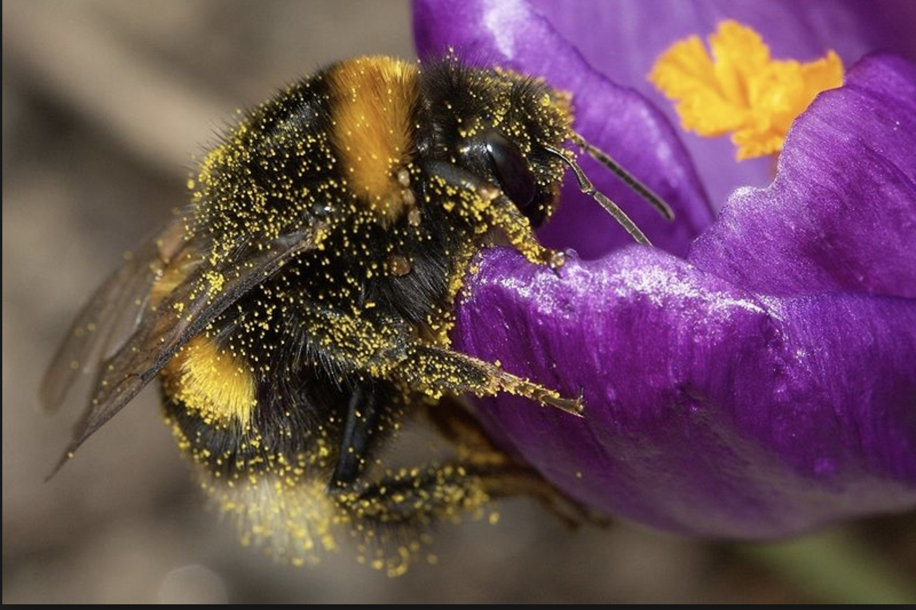 | In comparison with other pollinating insects like honeybees, bumblebees are very effective pollinators | Grow Native Plants and Wildflowers, particularly purple, blue & yellow with flat, single blossoms
Tachinid flies  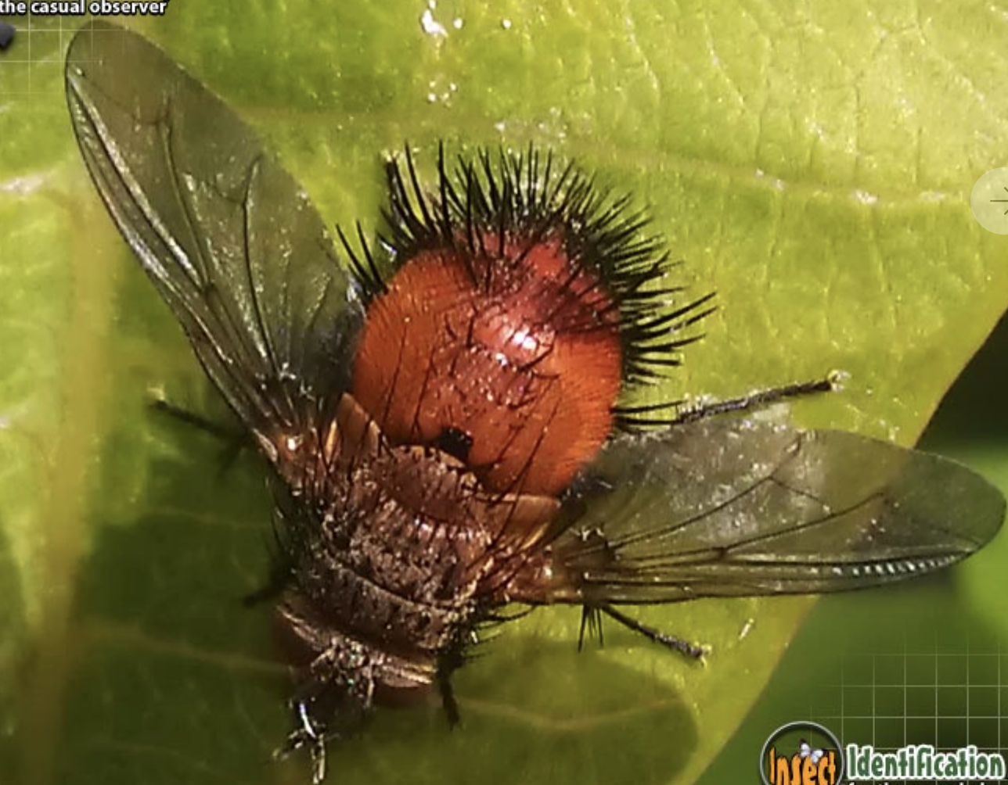 | Adult tachinid flies resemble small houseflies and may be covered in dark bristly hairs. The larvae are maggots that feed inside host insects. The adults are important pollinators and the larvae consume incredible amounts of pests. | Caterpillars, Beetle and Sawfly Larvae, True Bugs, Grasshoppers, Japanese Beetles
Damselflies  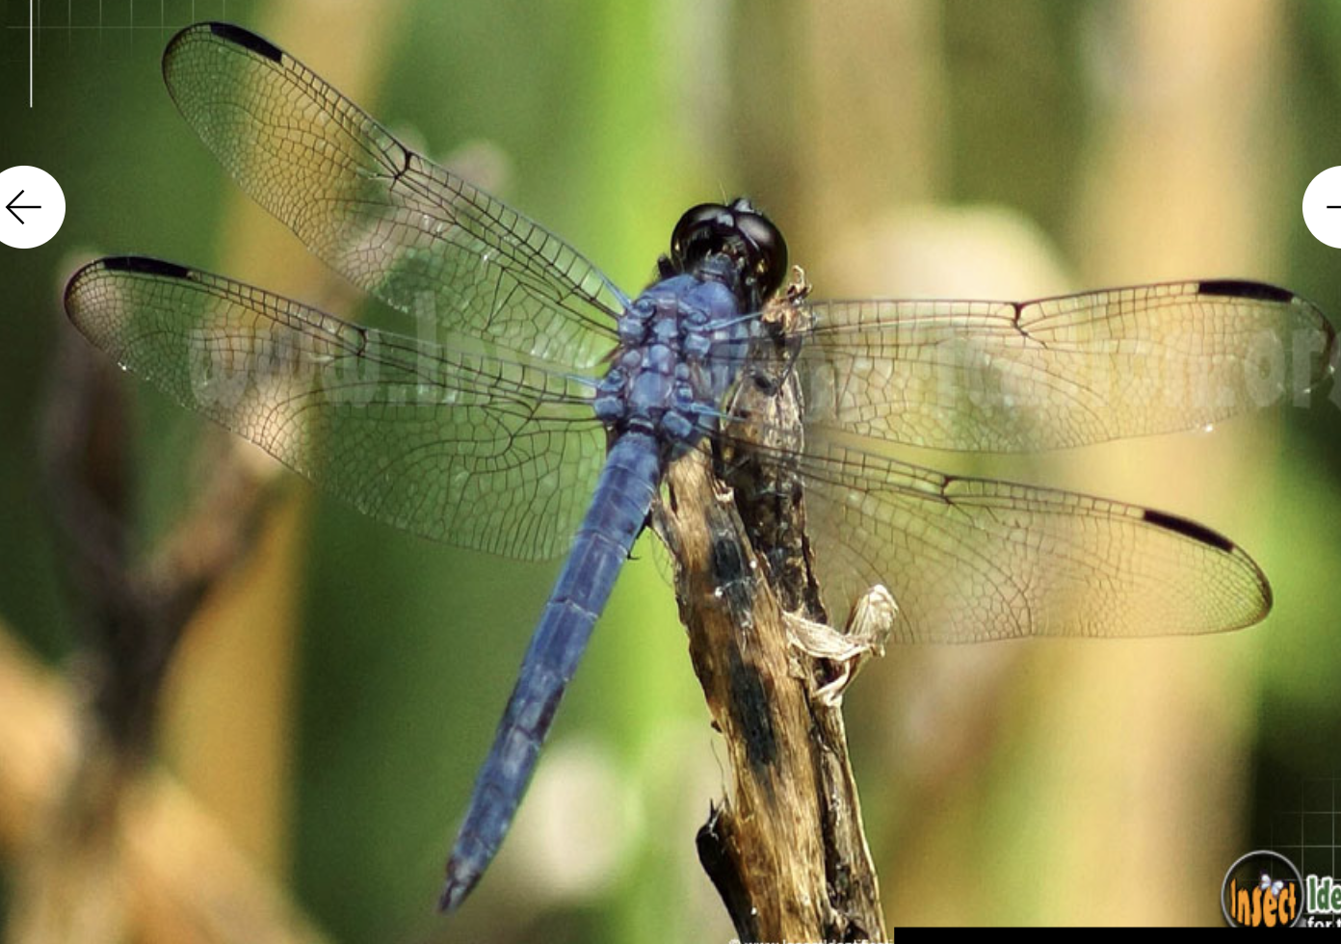 | Adults consume large quantities of other insects. They need clean water to breed. | Flies, Mosquitoes, Moths, Beetles, Caterpillars
Green Lacewing  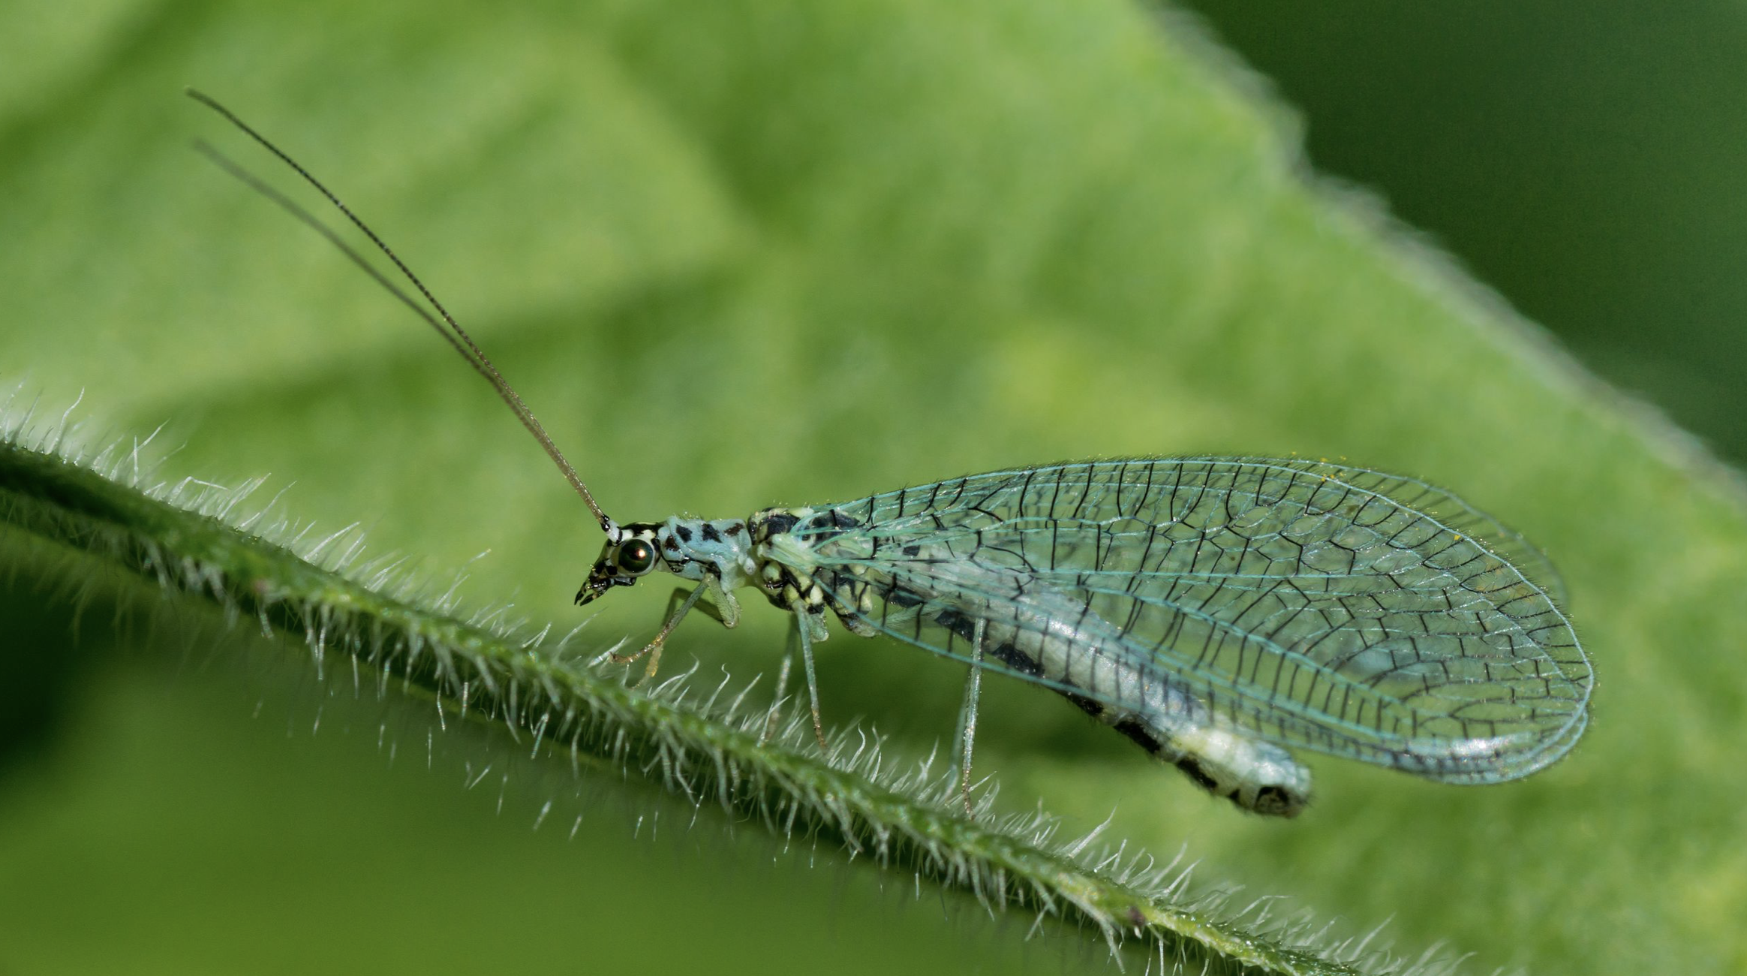 | In its larval stage — when it’s known as the “aphid lion” or “aphid wolf” — it’s a voracious consumer of problem insects, known to devour hundreds of aphids in a week, and is deadly to almost any soft-bodied insect pest and its eggs. In its adult stage, it feeds only on nectar and pollen. | Aphids, Thrips, Mealybugs, Whitefly, Leafhoppers, Small Caterpillars & Their Eggs
Lady Beetle  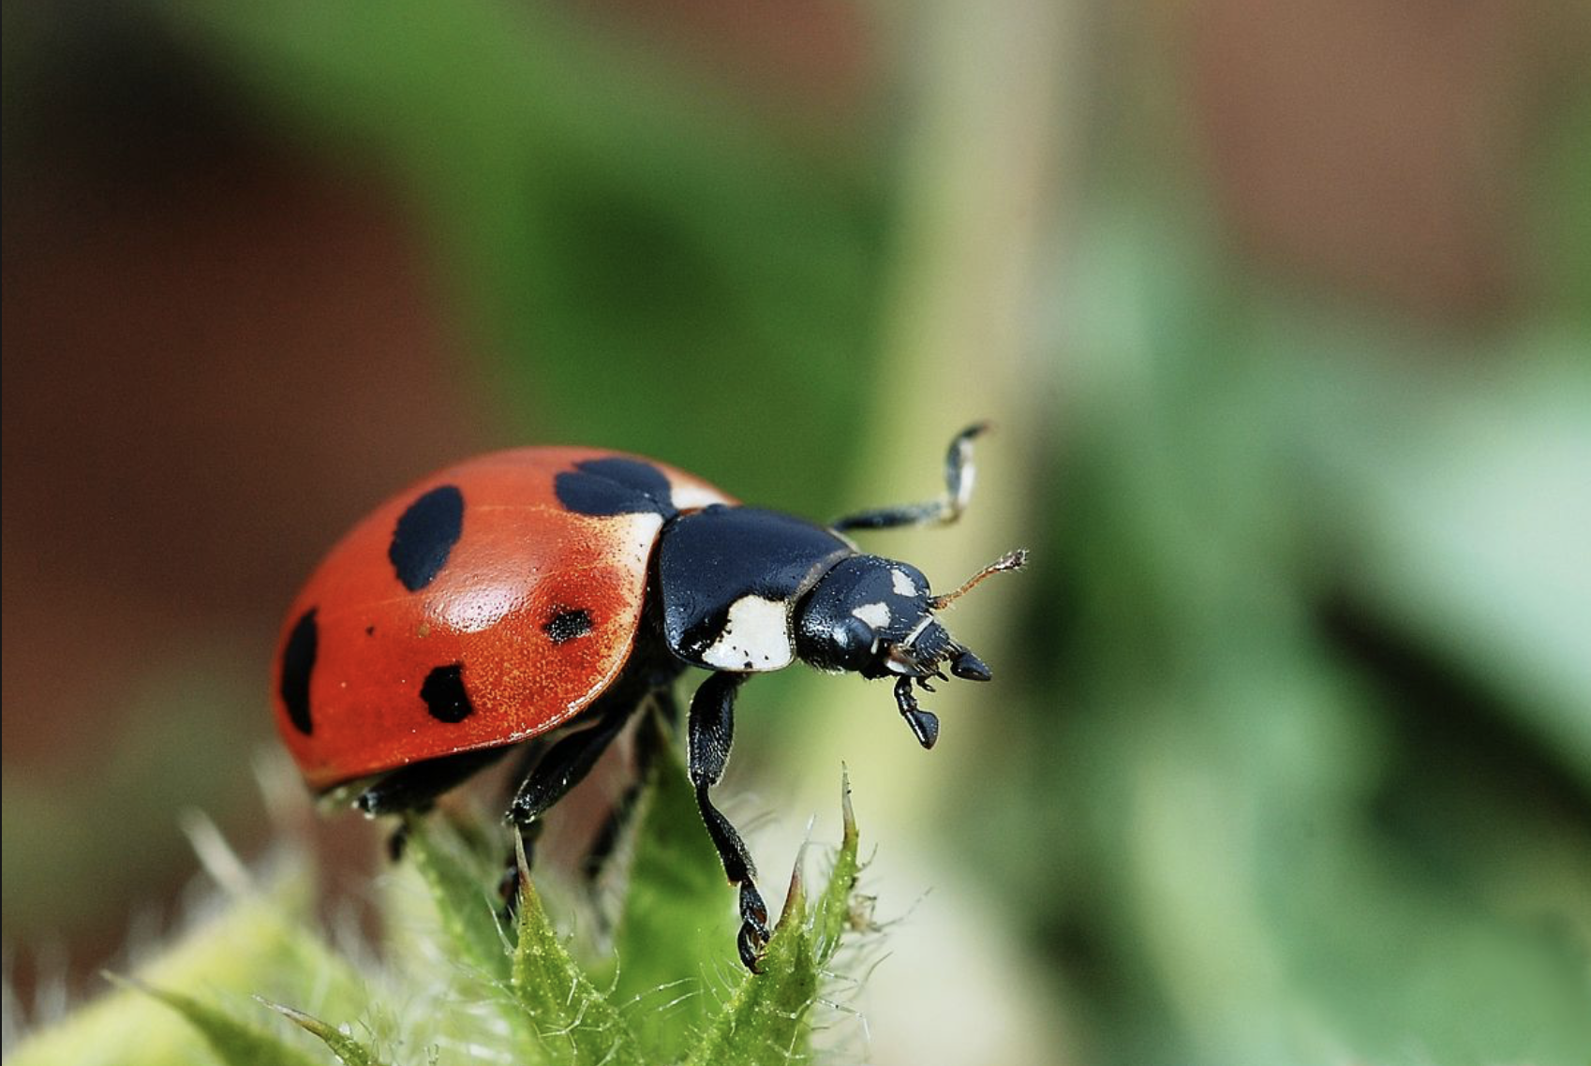 | Ladybugs, or lady beetles are the best-known garden predators available. There are over 400 types.  www.lostladybug.org is a site that is attempting to monitor the changes in native population. | Aphids, Scales/Mealybugs, Mites, Thrips Soft-Bodied Bugs, Insect Eggs
Hoverflies (Syrphid Flies)  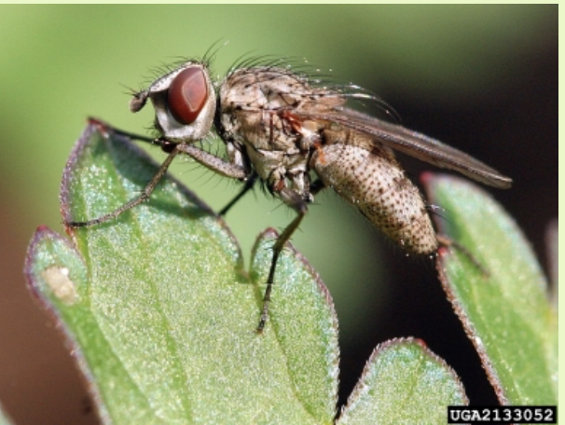 | They look very like small bees and wasps. They’re good pollinators and since they are active when temperatures are cooler, they’re useful early in an aphid infestation. | Aphids, Thrips, Scales/Mealybugs, Spider Mites
Parasitic Wasps  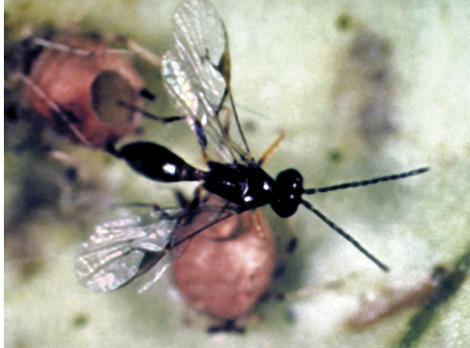 | Parasitic wasps are tiny, but their presence is of great importance. They are usually non-stinging and are harmless to humans, plants, and animals. Specific examples include the Leafminer Parasite, Aphid Parasite and the Fly Predator which is nature’s first line of defense against nuisance flies — including the common housefly and plays an important role in controlling flies around manure piles, chicken coops, corrals, garbage sites or any other place that might harbor flies and their maggots | Leafminers, Aphids, Houseflies, Asparagus Beetles, Leafhoppers, Cankerworms, Whiteflies, Caterpillars, Sawfly Larvae, Leafrollers, Gypsy Moths, Scales/Mealybugs, Beetle Larvae.
Pirate Bug  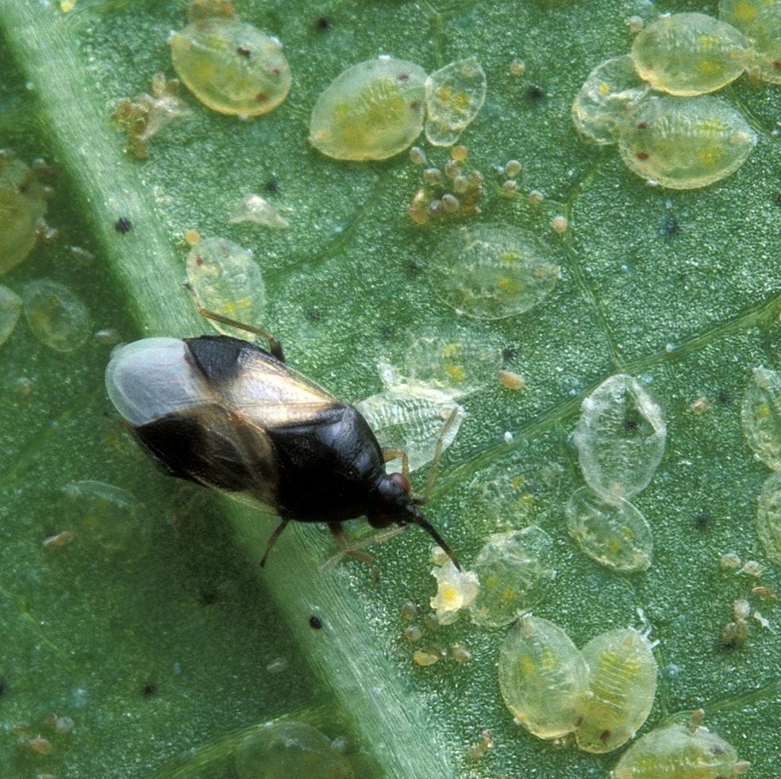 | Both adults and nymphs devour large amounts of prey. They are commonly found living on corn, soybeans, tomatoes and grain crops as well as on flowers and in landscapes. | Thrips, Mites, Scales/mealybugs, Aphids, Small caterpillars, Insect eggs
Soldier Bug  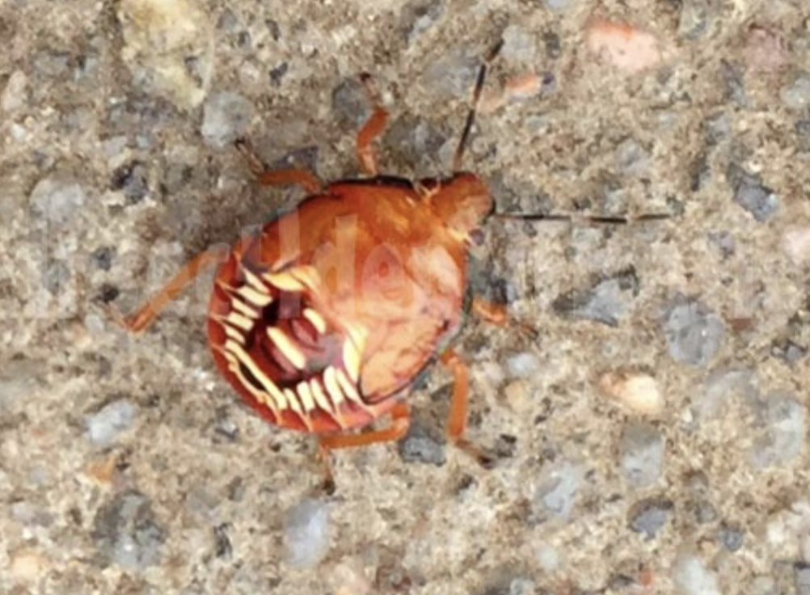 | Spined soldier bugs (Podisus maculiventris) prey on some of the most potentially-damaging grubs. | Caterpillars, Soft-Bodied Insect Pests
Ground Beetles  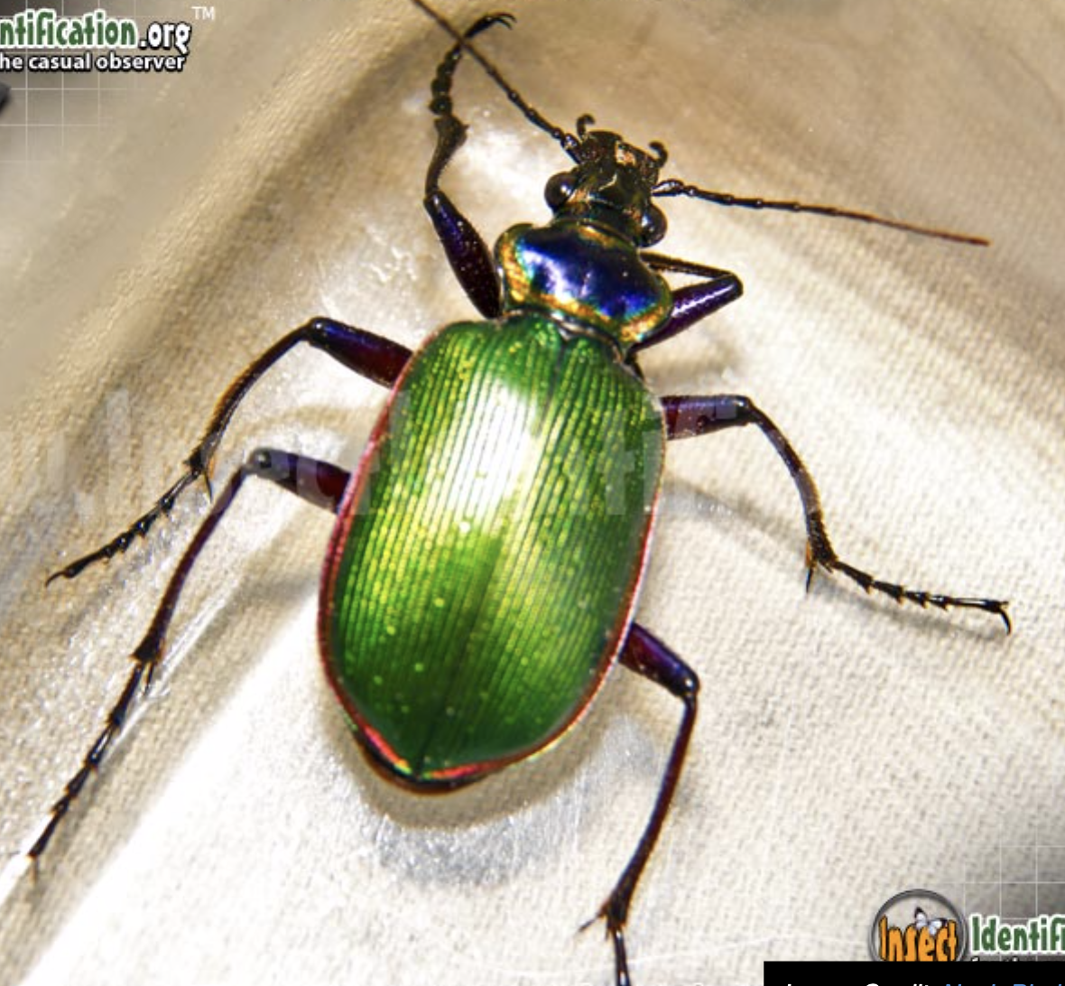 | Although most beetles are harmful to plants in the garden, ground beetles are not. Adults overwinter in garden trash or in soil. Rove beetles commonly shelter beneath stone or wooden walkways and are valuable decomposers, they also eat harmful insects such as snails, slugs, aphids, mites, and nematodes. | Slugs, Snails, Caterpillars, Grubs of Scarab Beetles, Eggs and Larvae of Ants, Aphids, Gypsy Moths, Nematodes, Spider Mites, Thrips, Fungus Gnats

Resources:
- Identifying Insects in New Jersey
https://www.insectidentification.org/insects-by-state.asp?thisState=New%20Jersey

- State of New Jersey Department of Agriculture
Phillip Alampi Beneficial Insect Rearing Laboratory
https://www.nj.gov/agriculture/divisions/pi/prog/beneficialinsect.html

